**Covid-19 Diagnosis System**

GROUP MEMBERS: Carlisha Nicholson, Sahailia Samuels, Ricardo Johnson

A BEGINNER’S GUIDE

**Getting Started on the** **Covid-19 Diagnosis Expert System**

**Adding a new Symptoms for a Variant to the Expert System**

**Step 1:** Click on the button, ***New Symptom*** button as indicated by the arrow***.*** The following window should open.

**Step 2:** Click on the button with variant you wish to add a symptom for. A window similar to the one below should open.

**Step 3:** Enter the new symptom associated with the variant chosen.

**Step 4:** Click the ***submit*** button to add the symptom to the database.

***Examples:***

**Adding Symptom for the Regular Covid-19 Variant**

**Outcome:** 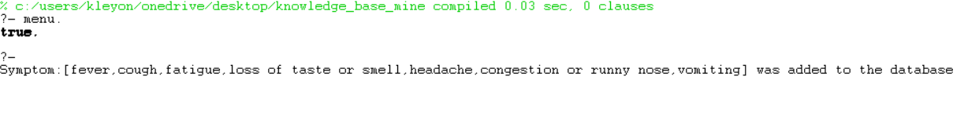

**Adding a Symptom for the Delta Variant**

**Outcome: **

**Adding a Symptom for the Omicron Variant**

**Outcome:**



**How To Add and View Underlying Condition Associated with the Omicron Variant**

**Step 1:** Click on the button, ***Underlying Condition.*** The following window should open.

**Step 2:** Click on the button, ***New Underlying Condition.*** The window below should open.

**Step 3:** Enter the new underlying condition and click the ***add*** button.

**Step 4:** A prompt should open asking if you would like to add another underlying condition.

**Step 5:** Click on the ***yes*** button if you wish to add another underlying condition, click ***no*** if not.

**Step 4:** To view the new underlying conditions added, click on the ***view underlying conditions*** button as indicated by the arrow***.***

***Example***

**Outcome:**



**Diagnosing a Patient**

**Step 1:** Enter Patient’s name, age, select their gender and enter their temperature.

**Step 2:** Select whether patient has been experiencing the symptoms, Dizzy, Fainting or Blurry Vision.

**Step 3:** Enter Patient’s Systolic and Diastolic Reading.

**Step 4:** Select the symptoms the patient is experiencing.

**Step 5:** Select the conditions that the patient or their family has a history of.

**Step 6:** Click the ***submit*** button. (See Examples below)

**Diagnosis of a patient with Omicron**

**Outcome:**

**Diagnosis of a Patient with the Regular Variant**

**Outcome:**

**Diagnosis of a Person with the Delta Variant**

**Outcome:**

**Viewing Covid-19 Statistics**

**Step 1:** Click on the ***Covid Statistics*** button as indicated by the arrow.

**Step 2:** A window should open showing the total cases, percentage of persons with mild symptoms, severe symptoms, the delta variant, the omicron variant, and omicron with underlying conditions (see example below).

**Patient User Manual**

**Diagnosing Yourself**

**Step 1:** Click on the ***diagnose patient*** button. The following window should open.

**Step 2:** Enter your name, age, select your gender and enter your temperature.

**Step 3:** Select whether you have been experiencing the symptoms, Dizzy, Fainting or Blurry Vision.

**Step 4:** Enter your Systolic and Diastolic Reading.

**Step 5:** Select the symptoms you are experiencing.

**Step 6:** Select the conditions that you or their family has a history of.

**Step 7:** Click the ***submit*** button. (See Example below)

***Example***

**Outcome :**

**Viewing Covid-19 Statistics**

